Data Handling and Visualization (DSA06)
Name: Prasanna M Reg. No: 1925260244
Set 16: Customer Demographics Analysis
Question 1. Create a bar chart to visualize the distribution of customer ages. Label the axes and title the chart.
Program (R):
library(ggplot2)
cust <- data.frame(Customer_ID = 1:3, Age = c(28,35,42),
Gender = c("Female","Male","Female"),
Income = c(50000,60000,75000))
cust$Age_Group <- cut(cust$Age, breaks = c(19,29,39,49), labels = c("20-29","30-39","40-49"))
ggplot(cust, aes(x = Age_Group)) +
geom_bar(fill = "steelblue", colour = "black") +
geom_text(stat = "count", aes(label = after_stat(count)), vjust = -0.3) +
labs(title = "Distribution of Customer Ages", x = "Age Group (years)", y = "Number of Customers") +
theme_minimal()
Output:
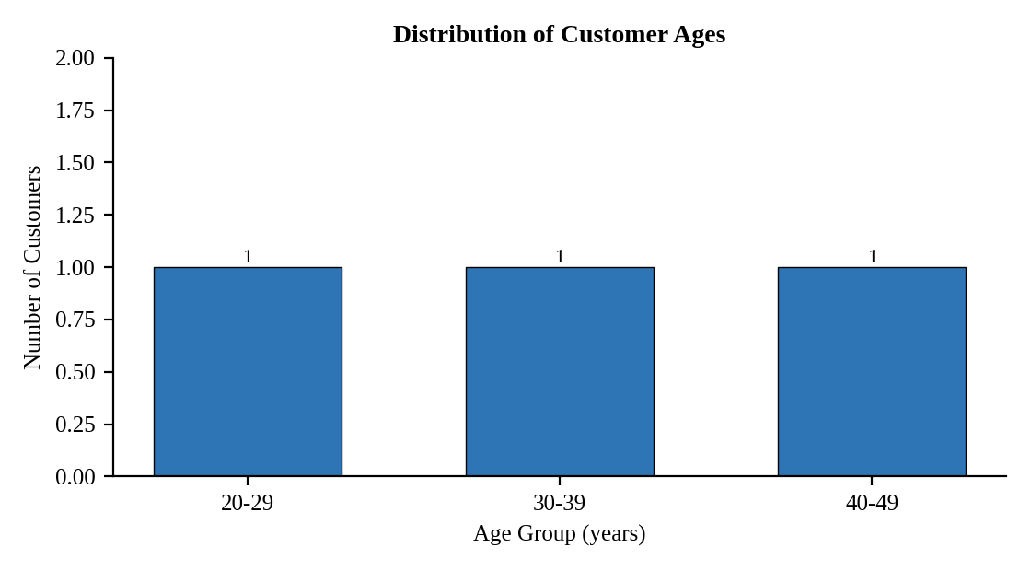
Interpretation:
The three customers fall into three different age groups (28, 35 and 42 years), one customer in each. The customer base is spread across the 20s, 30s and 40s with no concentration in a single group.

Question 2. Generate a pie chart to represent the distribution of customers by gender.
Program (R):
g <- as.data.frame(table(cust$Gender)); names(g) <- c("Gender","Count")
g$Pct <- round(100 * g$Count / sum(g$Count), 1)
ggplot(g, aes(x = "", y = Count, fill = Gender)) +
geom_col(width = 1, colour = "white") + coord_polar("y") +
geom_text(aes(label = paste0(Gender, " (", Pct, "%)")), position = position_stack(vjust = 0.5)) +
labs(title = "Customers by Gender") + theme_void()
Output:
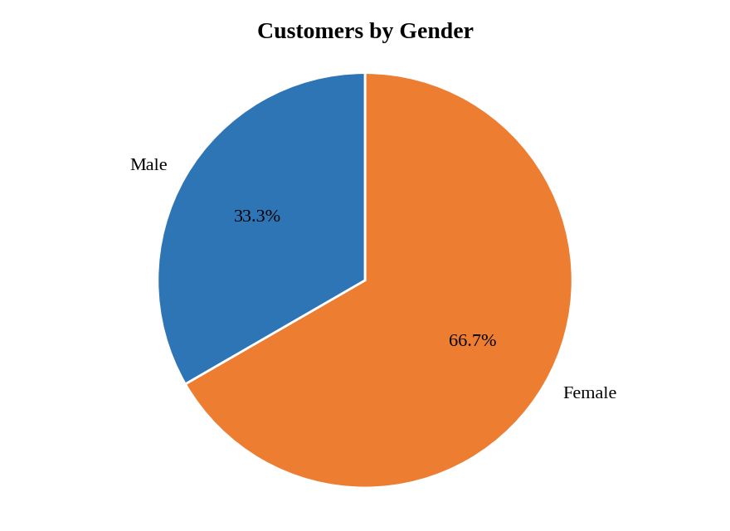
Interpretation:
Female customers form two thirds (66.7%) of the sample and male customers one third (33.3%). The customer base is female-dominated.

Question 3. Build a table to show the demographic information for each customer. Label the table elements.
Program (R):
library(knitr)
kable(cust[, c("Customer_ID","Age","Gender","Income")], align = "c",
col.names = c("Customer ID","Age","Gender","Income ($)"),
caption = "Table 16.1: Customer Demographic Information")
Output:
Table 16.1: Customer Demographic Information
Customer ID | Age | Gender | Income ($)
1 | 28 | Female | 50000
2 | 35 | Male | 60000
3 | 42 | Female | 75000

Interpretation:
Income increases with age: the 28-year-old earns 50000, the 35-year-old 60000 and the 42-year-old 75000. The average age is 35 years and the average income is 61666.67.

Question 4. Develop a Tableau dashboard combining the bar chart, pie chart, and the table for interactive exploration of customer demographics.
Procedure (Tableau):
1. Open Tableau, click Connect, choose Text file / Microsoft Excel, select "Customer_Demographics.csv" and open Sheet 1.
2. Create a calculated field Age Group = IF [Age] < 30 THEN "20-29" ELSEIF [Age] < 40 THEN "30-39" ELSE "40-49" END.
3. Sheet 1 (Bar): Columns = Age Group; Rows = COUNT(Customer ID); add labels and axis titles.
4. Sheet 2 (Pie): mark type = Pie; Color = Gender; Angle = COUNT(Customer ID); Label = Gender and Percent of Total.
5. Sheet 3 (Table): Rows = Customer ID; Columns = Measure Names; Text = Measure Values (Age, Gender, Income).
6. Click New Dashboard, name it "Customer Demographics Dashboard", set Size to Automatic and drag the sheets onto the canvas (charts on top, table below).
7. Select each chart and click the "Use as Filter" icon so that clicking a bar or slice filters the other sheets; keep tooltips enabled.
8. Add a title to every sheet, adjust labels and colours, and save the workbook (File > Save As, .twbx).

Output:
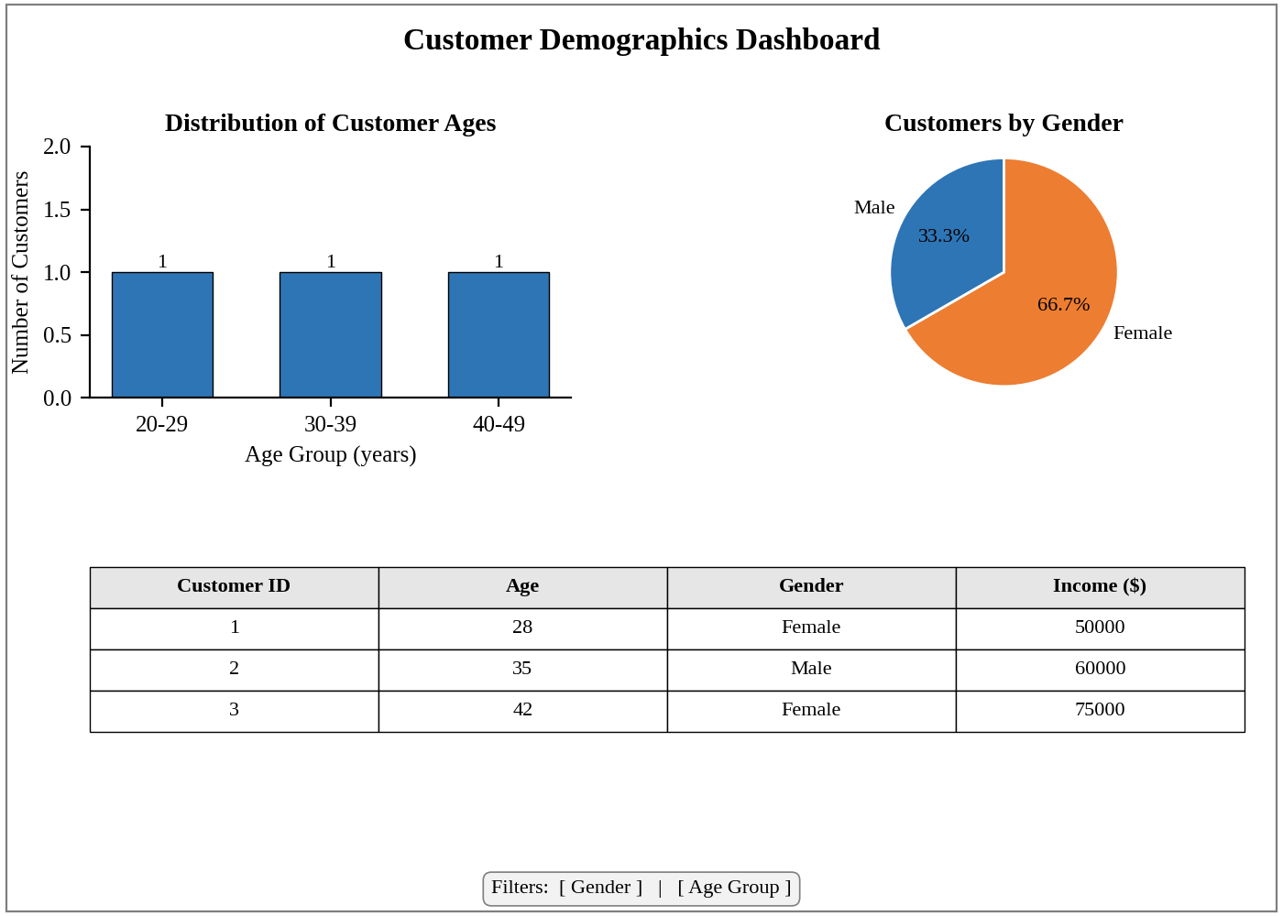
Dashboard layout (preview of the Tableau output).
Interpretation:
Selecting a gender slice or an age group highlights the matching customers in the table. The dashboard shows a female-majority base, one customer per age group, and income that rises with age.

